In this assignment, the diameter of a scaled free network was calculated using Dijkstra algorithm. The source code was tested for the following simple graph with five nodes and diameter 4 (test1.txt). The diameter of this graph equals to the distance between the first and the last node.

The code was also tested for the following circular graph with diameter of 2 (test2.txt).

I ran the code on provided scale free graphs (with size 10, 50, 100, 1000) and here are the results.

* Diameter of graph of size 10 = 3
* Diameter of graph of size 50 = 7
* Diameter of graph of size 100 = 8
* Diameter of graph of size 1000 = 14

I also generated graphs with size 1500, 2000, 2500, 5000, 10000 and found their diameters (**Please note that my submitted code for generating graphs has an issue of generating nodes starting at 1. I started the “*for loop”* in line 45 and 46 with 1 instead of zero. I corrected it and will submit it in the optional submission.**)

The following plot illustrates the relation of the number of nodes in a graph and its diameter.

The finding from this study shows that the diameter of a graph grows much slower than the growth of the number nodes in the graph. This is expected, since to move from any node to the other, one can first move to the hubs that most of the nodes are connected to, and then move the interested node. **Airport Traffic Network: Review to the literature**

The network representation of the air traffic illustrates the scale-free network characteristics. The study by Sridhar et al. [1] considered a graph representation of 8170 airports in the United States, and showed it has scale-free network characteristics. For example they showed that the node degrees follow the power law.

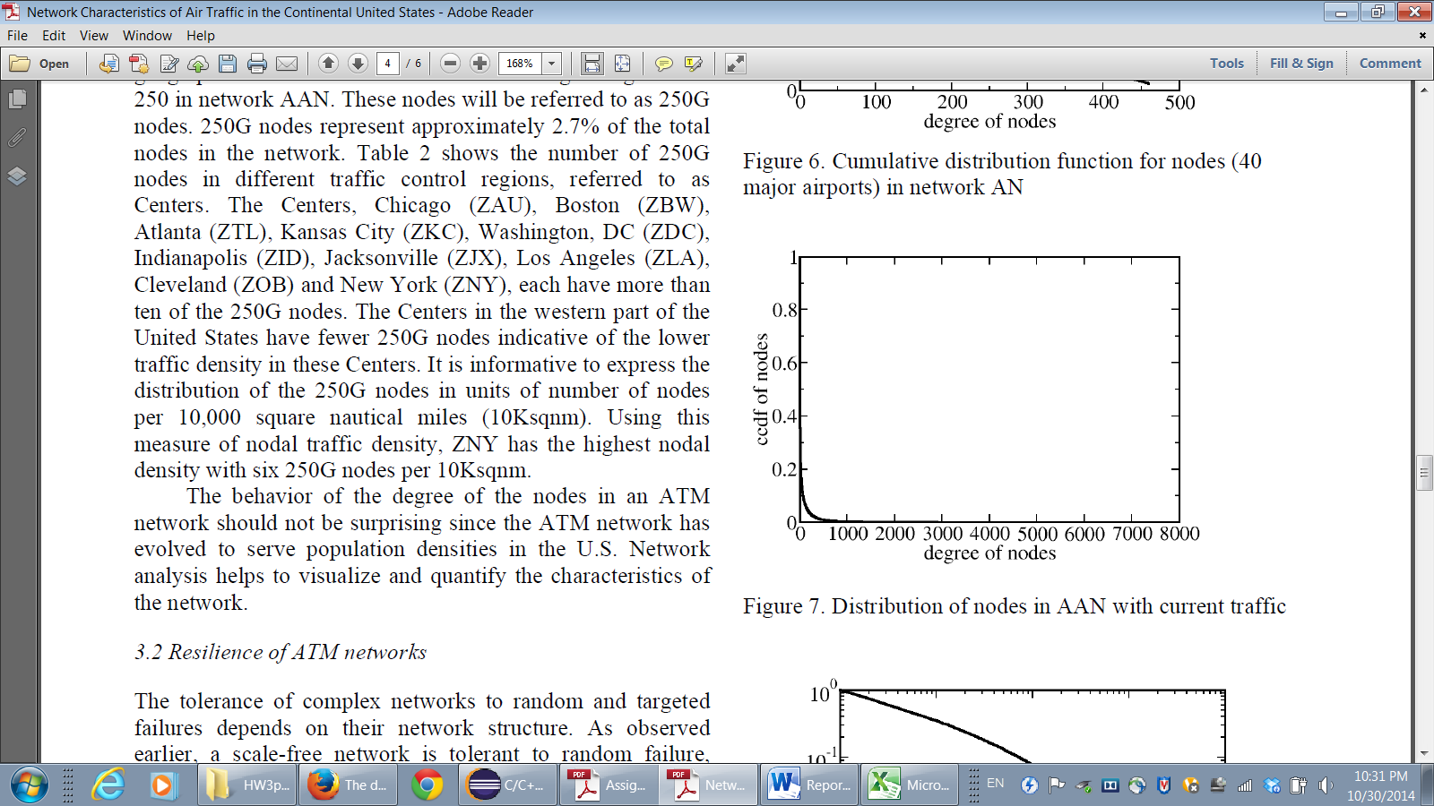

Similarly, Guimera et al. [2] illustrated the worldwide air traffic network follows the scale free network using empirical data. Another study by Han et al. [3] studied the European air traffic, and illustrated that this network follows the scale free characteristics.

In summary many studies evaluated the airline traffic in world, continental or national levels, and illustrated these networks have the scale free characteristics.

**References:**

1. Sridhar. B, Sheth. K, (2008) Network Characteristics of Air Traffic in the Continental United States. *proceedings of the 17th World Congress, The International Federation of Automatic Control.13109-13114.*
2. Guimera, R., Amaral, L.A.N., (2004). Modeling the world-wide airport network. Eur. Phys. J. B 38, 381–385.
3. Han, D.D., Qian, J.H., Liu,J.G.,(2009). Network topology and correlation features affiliated with European airline companies. *Physica A.* 388, 1–81.